ShowTime
Business Report

Predictive Modelling Coded Project
By
Rajesh Mambulli

Table of Contents
Predictive Modelling Coded Project 1
1. Context 6
2. Objective 6
3. Data Description 6
4. Data Dictionary: 7
5. Data Overview through Python 7
5.1 Checking for missing values in the data. 8
5.2 Checking for duplicate values in the data. 8
5.3 Checking the statistical summary of the numerical data. 8
6.0 Univariate Analysis 10
6.1 Observations on visitors 10
6.2 Observations on ad_impressions 11
6.3 Observations on major_sports_event 12
6.4 Observations on views_trailer 12
6.5 Observations on views_content 13
6.6 Observations on genre 14
6.7 Observations on dayofweek 15
6.7 Observations on season 15
7.0 Bivariate Analysis 16
7.1 Observations on views_content and views_trailer. 17
7.2 Observations on views_content and dayofrelease 17
7.3 Observations on views_content and season 18
8.0 Finding Outliers 19
9.0 Data Preparation for Modelling 20
10.0 Model Building - Linear Regression 22
10.1 Model Performance Check 23
10.1 Checking Linear Regression Assumptions 23
11.0 Predictions on test data 28
12.0 Final Model summary 29
13.0 Linear Model Mathematical Equation. 30
14.0 Conclusions and Recommendations 30
15.0 Answers to EDA questions 31
1. What does the distribution of content views look like? 31
2. What does the distribution of genres look like? 32
3. The day of the week on which content is released generally plays a key role in the viewership. How does the viewership vary with the day of release? 32
4. How does the viewership vary with the season of release? 33
5. What is the correlation between trailer views and content views? 34

Table of Figures
Figure 1: Top 5 rows of data 7
Figure 2: Data Types of attributes 8
Figure 3: Null checks in the data 8
Figure 4: Duplicate checks in the data 8
Figure 5: Statistical summary of data 9
Figure 6: Distribution of visitor’s attribute 10
Figure 7: outliers in the visitors attribute 10
Figure 8: Distribution of ad_impressions attribute 11
Figure 9: Outliers in ad_impressions attribute 11
Figure 10: Distribution of Major_sports_event attribute 12
Figure 11: Distribution of views_trailer attribute 12
Figure 12: Outliers in views_trailer attribute 13
Figure 13: Distribution of views_content attribute 13
Figure 14: outliers of view_content attribute 14
Figure 15: Distribution of genre 14
Figure 16: Distribution of day of week attribute 15
Figure 17: Distribution of season attribute 15
Figure 18: Heat map of numerical data. 16
Figure 19: relation between views_content and views_trailer 17
Figure 20: Summary of day of release and views_content 17
Figure 21: Day of week vs views_content 18
Figure 22: summary of views_content and season 18
Figure 23: Season vs views_content 19
Figure 24: Outliers in Numerical data. 19
Figure 25: Percentage of outliers in numerical columns 20
Figure 26: Data split evidence 20
Figure 27: Evidence of adding constant and adding dummy variables 21
Figure 28: Converting Boolean values to Float values. 21
Figure 29: Evidence of Test and Train split of Data 21
Figure 30: Regression Summary 22
Figure 31: Model Performance Summary of Train data 23
Figure 32: VIF of Features 24
Figure 33: Regression Summary 25
Figure 34: Train Data Performance 25
Figure 35: Test Data Performance 25
Figure 36: Checking Residuals 26
Figure 37: Scatter Plot of Residuals 26
Figure 38: Normality of Residuals 27
Figure 39: Q-Q Plot of Residuals 27
Figure 40: Shapiro test evidence 28
Figure 41: Evidence of Homoscedasticity 28
Figure 42: Predictions of Test data 28
Figure 43: Final Model Summary 29
Figure 44: Final Model Training data Performance 29
Figure 45: Test data Performance 29
Figure 46: Distribution of views_content attribute 31
Figure 47: Outliers in views_content attribute 31
Figure 48: Distribution of genre attribute 32
Figure 49: Summary of views_content by day of week 32
Figure 50: dayofweek vs views_content 33
Figure 51: Summary of views_content with season 33
Figure 52: views_content vs season 34
Figure 53: views_trailer vs views_content 34
Figure 54: views_trailer vs views_content correlation 35

Context
An over-the-top (OTT) media service is a media service offered directly to viewers via the internet. The term is most synonymous with subscription-based video-on-demand services that offer access to film and television content, including existing series acquired from other producers, as well as original content produced specifically for the service. They are typically accessed via websites on personal computers, apps on smartphones and tablets, or televisions with integrated Smart TV platforms.

Presently, OTT services are at a relatively nascent stage and are widely accepted as a trending technology across the globe. With the increasing change in customers' social behaviour, which is shifting from traditional subscriptions to broadcasting services and OTT on-demand video and music subscriptions every year, OTT streaming is expected to grow at a very fast pace. The global OTT market size was valued at $121.61 billion in 2019 and is projected to reach $1,039.03 billion by 2027, growing at a CAGR of 29.4% from 2020 to 2027. The shift from television to OTT services for entertainment is driven by benefits such as on-demand services, ease of access, and access to better networks and digital connectivity.

With the outbreak of COVID19, OTT services are striving to meet the growing entertainment appetite of viewers, with some platforms already experiencing a 46% increase in consumption and subscriber count as viewers seek fresh content. With innovations and advanced transformations, which will enable the customers to access everything they want in a single space, OTT platforms across the world are expected to increasingly attract subscribers on a concurrent basis.

Objective
ShowTime is an OTT service provider and offers a wide variety of content (movies, web shows, etc.) for its users. They want to determine the driver variables for first-day content viewership so that they can take necessary measures to improve the viewership of the content on their platform. Some of the reasons for the decline in viewership of content would be the decline in the number of people coming to the platform, decreased marketing spends, content timing clashes, weekends, and holidays, etc. They have hired you as a Data Scientist, shared the data of the current content in their platform, and asked you to analyse the data and come up with a linear regression model to determine the driving factors for first-day viewership.

Data Description
The data contains the different factors to analyse for the content. The detailed data dictionary is given below.

Data Dictionary:
- visitors: Average number of visitors, in millions, to the platform in the past week
- ad_impressions: Number of ad impressions, in millions, across all ad campaigns for the content (running and completed)
- major_sports_event: Any major sports event on the day
- genre: Genre of the content
- dayofweek: Day of the release of the content
- season: Season of the release of the content
- views_trailer: Number of views, in millions, of the content trailer
- views_content: Number of first-day views, in millions, of the content

Data Overview through Python
Data which is stored in csv file is imported to Jupyter Notebook with the help of pandas, NumPy libraries and used matplotlib and seaborn libraries to help with data visualization. Dataset is stored in python variable named data.

Understanding the shape of the dataset.
This dataset contains 1000 rows and 8 columns.
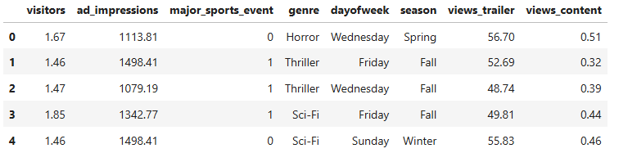
Figure 1: Top 5 rows of data

Checking the data types of data.
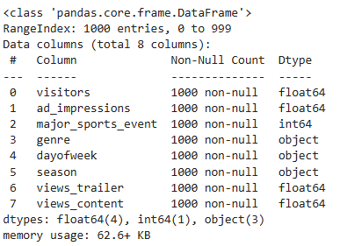
Figure 2: Data Types of attributes
All the Numerical attributes are in either int or float datatype which is desired. And remaining categories are string object type.
This concludes there is no need to change the data types of any attributes listed in the dataset.

Checking for missing values in the data.
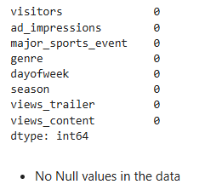
Figure 3: Null checks in the data

Checking for duplicate values in the data.
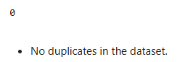
Figure 4: Duplicate checks in the data

Checking the statistical summary of the numerical data.

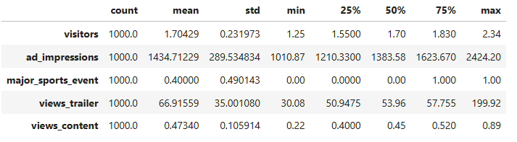
Figure 5: Statistical summary of data
Visitors
The dataset consists of 1000 entries with the number of visitors. On average, there are approximately 1.704 visitors, with a standard deviation of 0.232. The minimum number of visitors recorded is 1.25, and the maximum is 2.34. The data is fairly cantered around 1.7, as evidenced by the median value.
Ad Impressions
This dataset shows the number of ad impressions with a mean value of 1434.71 and a standard deviation of 289.53. This suggests that while most impressions are around the average, there is a considerable spread. The minimum number of impressions is 1010.87, while the highest reaches 2424.20. Quartiles indicate that 25% of the data falls below 1210.33, and 75% falls below 1623.67.
Major Sports Event
This categorical variable indicates whether a major sports event is taking place. The mean value of 0.40, combined with a standard deviation of 0.49, suggests that sports events occur less frequently than not. The minimum and median values are 0, while the maximum is 1, indicating some instances of such events.
Views Trailer
The number of trailer views averages 66.92, with a standard deviation of 35.00, which shows high variability. The dataset ranges from 30.08 to 199.92 views. The lower quartile is around 50.95, and the upper quartile is approximately 57.76, indicating that most of the data is concentrated between these values.
Views Content
For views of the main content, the average value is 0.47 with a standard deviation of 0.11, The minimum value is 0.22 and the maximum is 0.89, with the median at 0.45. Quartiles indicate that 25% of the data is below 0.40 and 75% is below 0.52.

6.0 Univariate Analysis
Let us check the distribution for numerical columns.

6.1 Observations on visitors
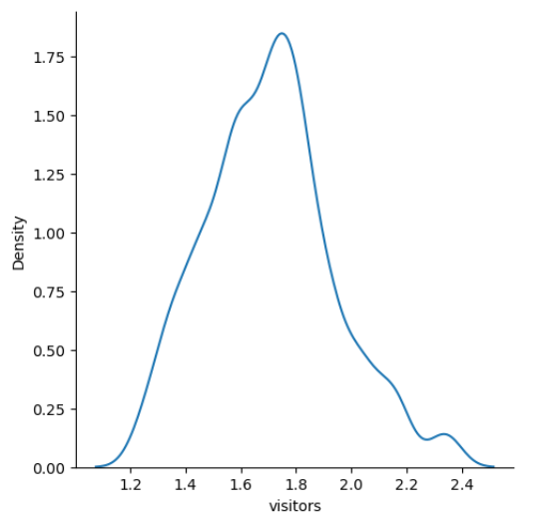
Figure 6: Distribution of visitor’s attribute

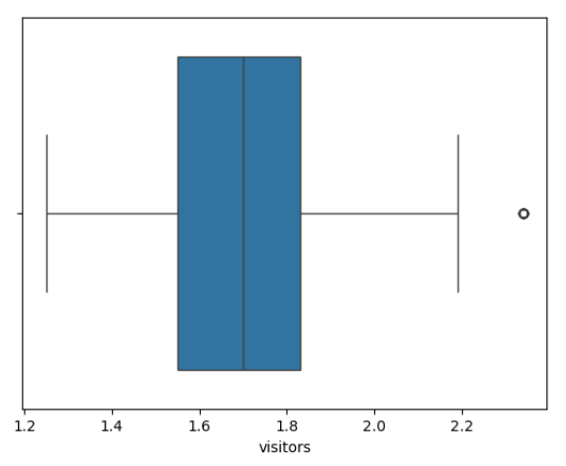
Figure 7: outliers in the visitors attribute

From the above 2 plots below mentioned are the observations
- The distribution is normal
- There is one outlier present in this visitor’s column.
- Values above 2.2 million are being represented as outliers in the boxplot.

6.2 Observations on ad_impressions
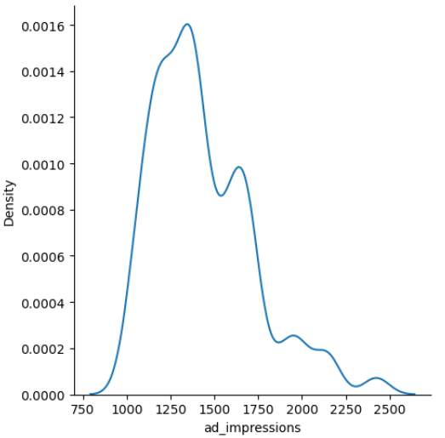
Figure 8: Distribution of ad_impressions attribute

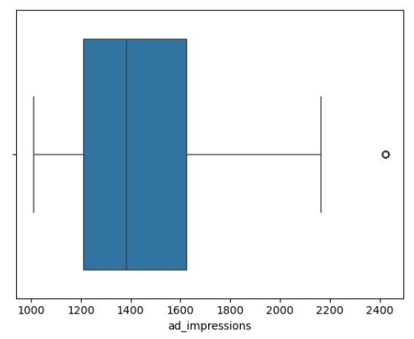
Figure 9: Outliers in ad_impressions attribute

From the above 2 plots below mentioned are the observations
- The distribution is skewed towards the right.
- There is one outlier present in this ad_impressions column.

6.3 Observations on major_sports_event
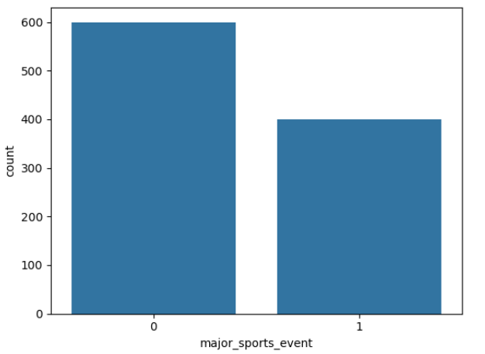
Figure 10: Distribution of Major_sports_event attribute
From the above plot below mentioned are the observations
Data contains 40% Major Sports event data and 60% No Major Sports event data on the day the content released.

6.4 Observations on views_trailer

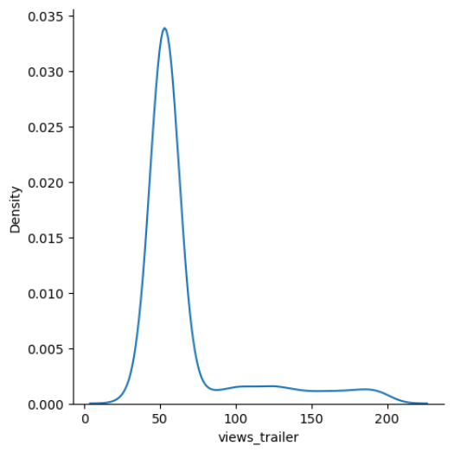
Figure 11: Distribution of views_trailer attribute
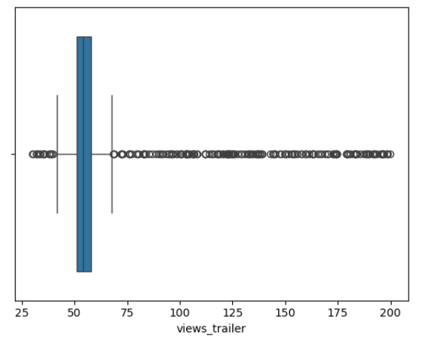
Figure 12: Outliers in views_trailer attribute
From the above plot below mentioned are the observations
- data is skewed towards right.
- There are many outliers in this attribute.

6.5 Observations on views_content
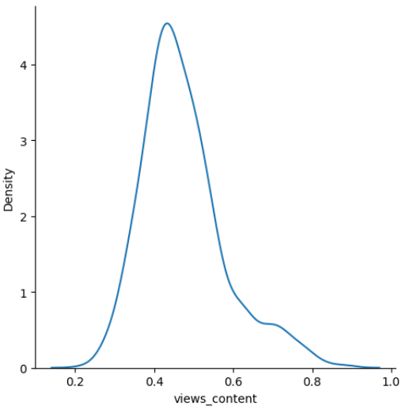
Figure 13: Distribution of views_content attribute
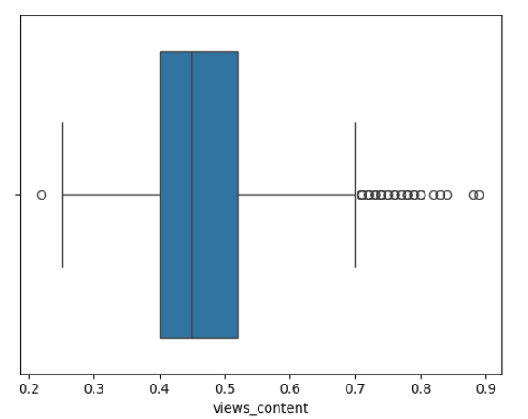
Figure 14: outliers of view_content attribute

From the above plot below mentioned are the observations
- Data is slightly skewed towards right.
- There are some outliers in this attribute.
- We will see will we Require Outlier treatment using IQR method.

6.6 Observations on genre
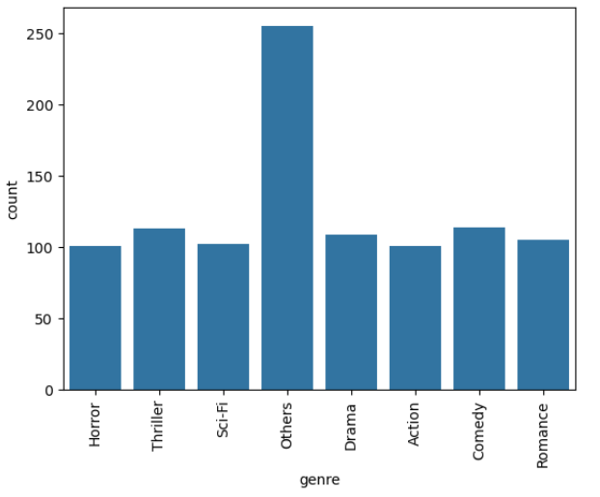
Figure 15: Distribution of genre
- All the genres are having more or less equal count of content. But majority is categorized as others
- Thriller and Comedy Genres have most content next to other genres.

6.7 Observations on dayofweek
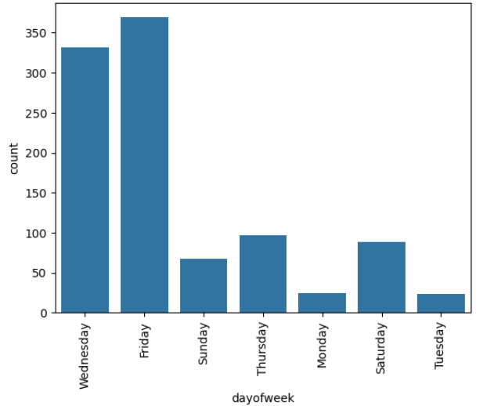
Figure 16: Distribution of day of week attribute
- Most of the content released are on Friday and Wednesday.
- Monday and Tuesday have a smaller number of contents released.

6.7 Observations on season
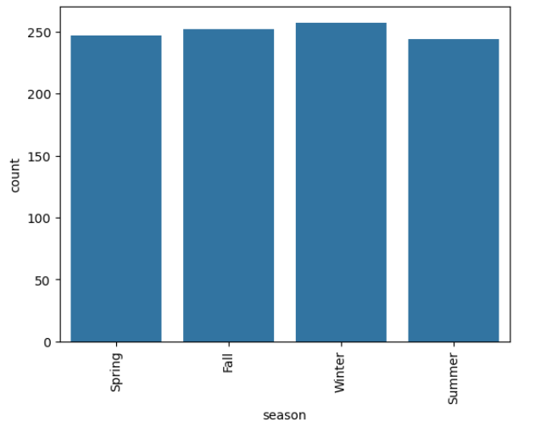
Figure 17: Distribution of season attribute

- Comparatively speaking all the Seasons has equal amounts of content releases.
- Winter has most number of releases.

7.0 Bivariate Analysis
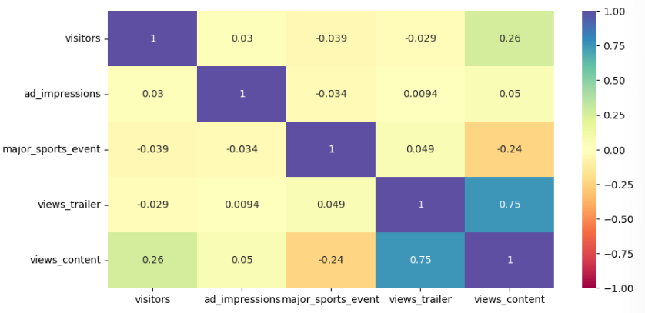
Figure 18: Heat map of numerical data.
Below mentioned are the observations.
- views_content shows high correlation with views_trailer. This indicates that people who sees trailer sees content on the same day.
- major_sports_event shows negative correlation with views_content. This indicates that on sports day content view on OTT is getting negatively impacted.
- views_content has positive correlation with visitors.
- ad_impressions has positive correlation but not that compared to other attributes in the data.

7.1 Observations on views_content and views_trailer.

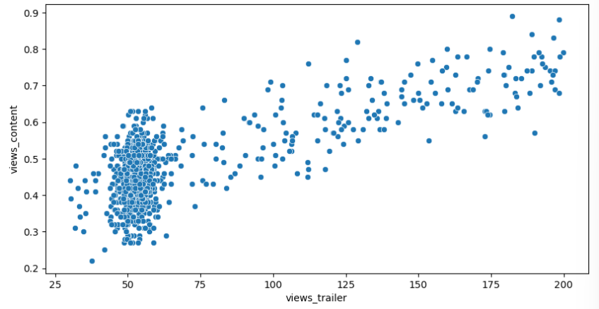
Figure 19: relation between views_content and views_trailer
- A positive correlation or an increasing trend can be clearly observed between views_trailer and views_content.

7.2 Observations on views_content and dayofrelease
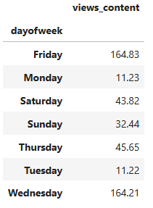
Figure 20: Summary of day of release and views_content

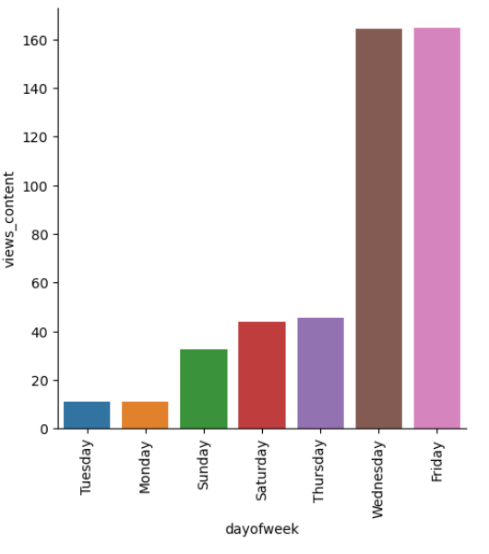
Figure 21: Day of week vs views_content
Observations on above 2 graphs
- First day views_count is more for the content which release on Wednesday and Friday.
- Content released on Friday has more total number of First day views.
- Content released on Wednesday is in next in line beside Friday wrt to First day total views.
- Content released on Tuesday has least total number of First day views compared to all other days.

7.3 Observations on views_content and season
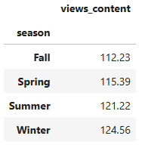
Figure 22: summary of views_content and season
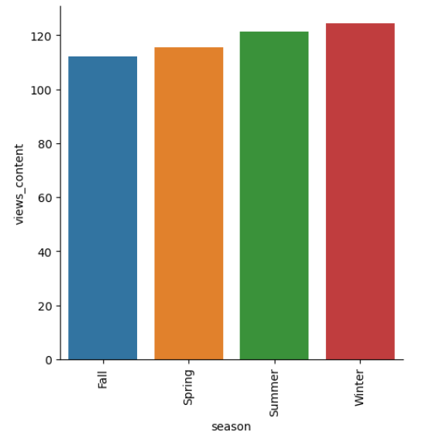
Figure 23: Season vs views_content
Observations from above 2 graphs
- Content released in Winter season has higher First day viewership
- Content released in summer season is higher First day viewership next to winter.
- Content released in Fall season has least total First day viewership compared to all the other seasons.

8.0 Finding Outliers
Finding outliers on numerical columns.
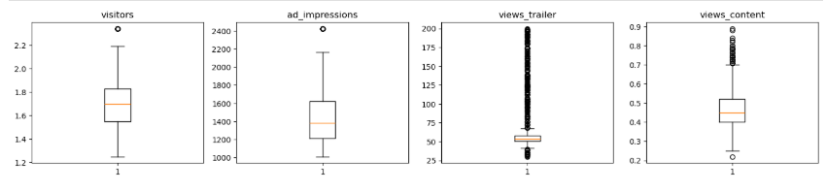
Figure 24: Outliers in Numerical data.
Each of the 4 numerical attributes contain outliers but these are real values which are true in nature in Realtime. So, treating them would be manipulating the data which in turn effects the predictive model later half of the project.

Percentages of Outliers in each column
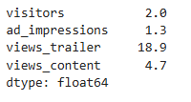
Figure 25: Percentage of outliers in numerical columns
- There are quite a lot outliers in the data.
- However, we will not treat them as they are proper values.

9.0 Data Preparation for Modelling
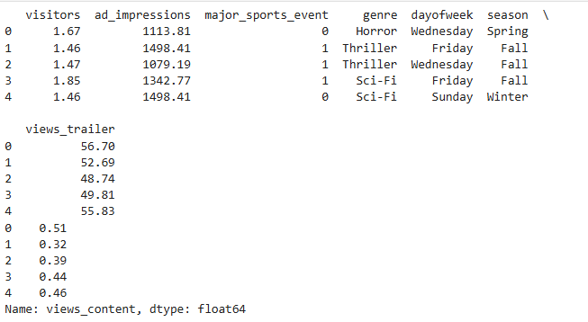
Figure 26: Data split evidence
Divided the X and Y variables in the data X being all the other attributes except the views_content field.
Adding constant to the X data and creating dummy variables for categorical variables.
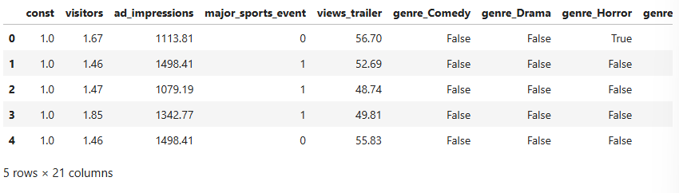
Figure 27: Evidence of adding constant and adding dummy variables
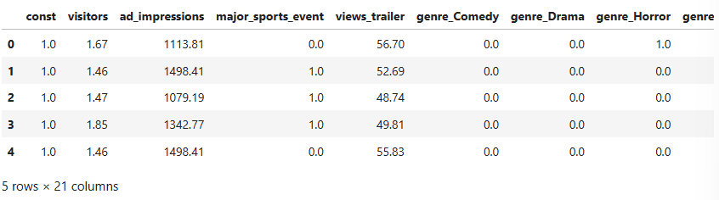
Figure 28: Converting Boolean values to Float values.
Replacing all the Boolean variables which were created above to the Float datatype.

Splitting the data into Train and Test data based on rule 70 and 30 respectively.
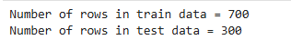
Figure 29: Evidence of Test and Train split of Data

10.0 Model Building - Linear Regression
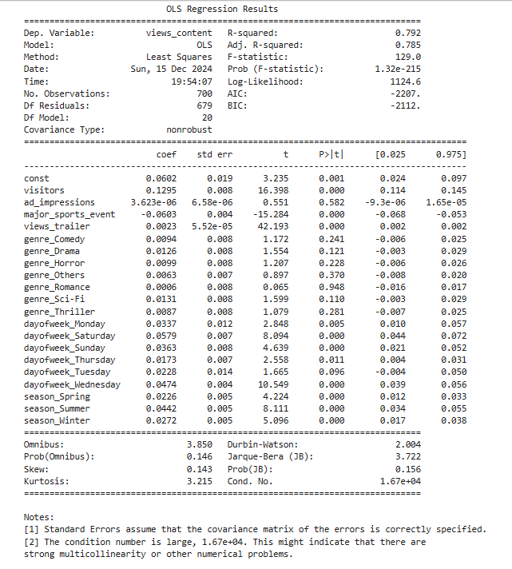
Figure 30: Regression Summary
R-squared:
* The value for R-squared is 0.792, which is good.
Adjusted. R-squared:
* The value for adj. R-squared is 0.785, which is good.
Const coefficient:
* The value for const coefficient is 0.0602

10.1 Model Performance Check

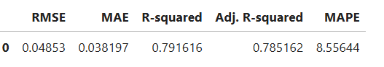
Figure 31: Model Performance Summary of Train data
Observations
- The training R2 is 0.79, so the model is not underfitting
- The train and test RMSE and MAE are comparable, so the model is not overfitting either
- MAE suggests that the model can predict First day viewership within a mean error of 0.034 on the test data
- MAPE of 12.6 on the test data means that we are able to predict within 8.55% of the First day viewership.

10.1 Checking Linear Regression Assumptions

We will be checking the following Linear Regression assumptions:
- No Multicollinearity
- Linearity of variables
- Independence of error terms
- Normality of error terms
- No Heteroscedasticity

10.1.1 TEST FOR MULTICOLLINEARITY

General Rule of thumb:
If VIF is between 1 and 5, then there is low multicollinearity.
If VIF is between 5 and 10, we say there is moderate multicollinearity.
If VIF is exceeding 10, it shows signs of high multicollinearity.

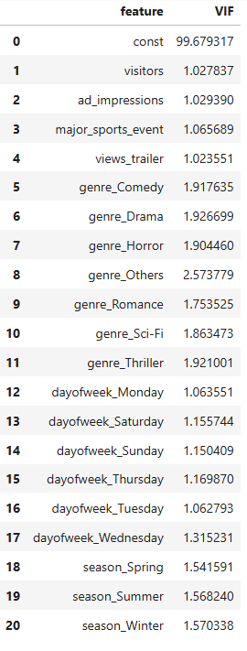
Figure 32: VIF of Features
Observations on above image.
- There are no multiple columns with very high VIF values, indicating no presence of multicollinearity
- We will systematically drop numerical columns with VIF > 5
- We will ignore the VIF values for dummy variables and the constant (intercept)

10.1.2 Dealing with high p-value variables

After dropping of all the variables whose p value greater than 0.05
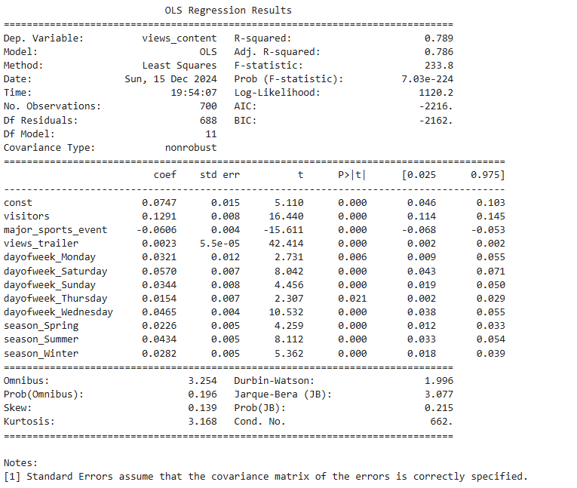
Figure 33: Regression Summary
Training Performance
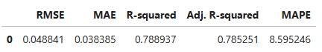
Figure 34: Train Data Performance

Test Performance
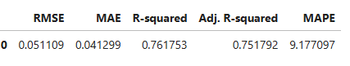
Figure 35: Test Data Performance
Observations
- Now no feature has p-value greater than 0.05, so we'll consider the features in x_train2 as the final set of predictor variables and olsmod2 as the final model to move forward with
- Now adjusted R-squared is 0.785, i.e., our model is able to explain ~79% of the variance
- The adjusted R-squared in olsmod1 (where we considered the variables without multicollinearity) was 0.785
  - This shows that the variables we dropped were not affecting the model
- RMSE and MAE values are comparable for train and test sets, indicating that the model is not overfitting.
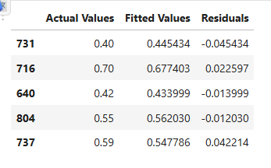
Figure 36: Checking Residuals
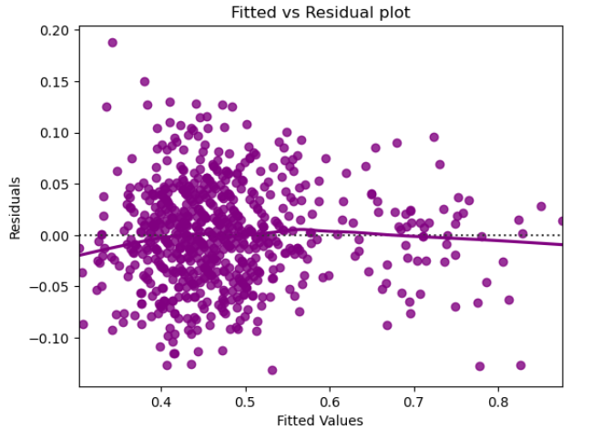
Figure 37: Scatter Plot of Residuals
- The scatter plot shows the distribution of residuals (errors) vs fitted values (predicted values).
- We see no pattern in the plot above. Hence, the assumptions of linearity and independence are satisfied.

10.1.3 TEST FOR NORMALITY

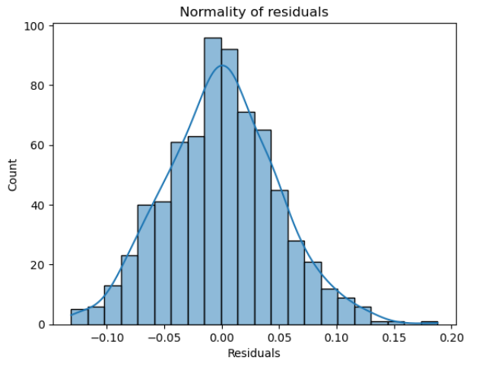
Figure 38: Normality of Residuals
Observations
- The histogram of residuals does have a bell shape.

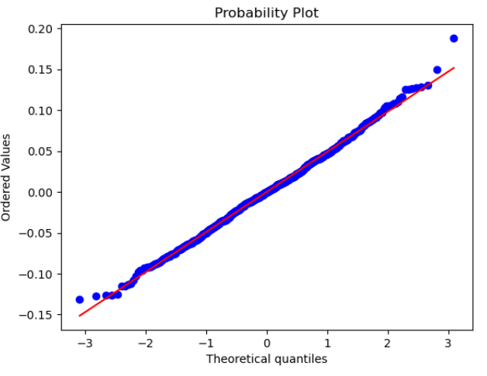
Figure 39: Q-Q Plot of Residuals
Observations
- The residuals more or less follow a straight line except for the tails.
Figure 40: Shapiro test evidence
- Since p-value > 0.05, the residuals are not normal as per the Shapiro-Wilk test.
- Strictly speaking, the residuals are not normal.
- However, as an approximation, we can accept this distribution as close to being normal.
- So, the assumption is satisfied.

10.1.4 TEST FOR HOMOSCEDASTICITY
Figure 41: Evidence of Homoscedasticity
Since p-value > 0.05, we can say that the residuals are homoscedastic. So, this assumption is satisfied.

11.0 Predictions on test data
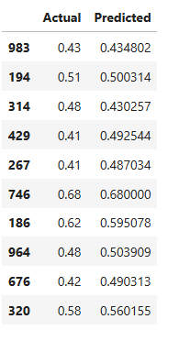
Figure 42: Predictions of Test data

- We can observe here that our model has returned pretty good prediction results, and the actual and predicted values are comparable.

12.0 Final Model summary
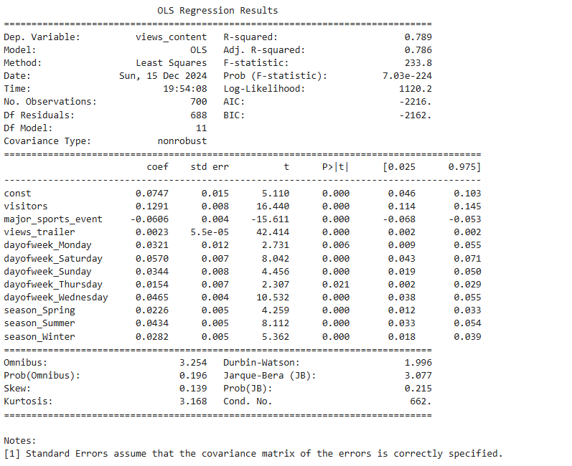
Figure 43: Final Model Summary
Training Performance
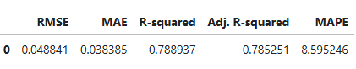
Figure 44: Final Model Training data Performance
Test Performance
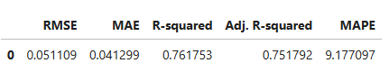
Figure 45: Test data Performance
- The model is able to explain ~79% of the variation in the data
- The train and test RMSE and MAE are low and comparable. So, our model is not suffering from overfitting
- The MAPE on the test set suggests we can predict within 9.2% of the First day viewership of content.
- Hence, we can conclude the model olsmodel_final is good for prediction as well as inference purposes.

13.0 Linear Model Mathematical Equation.

views_content = 0.07467052053721349 + 0.129095818258941 * ( visitors ) + -0.060555078181373276 * ( major_sports_event ) + 0.0023308167861640127 * ( views_trailer ) + 0.032065806790236344 * ( dayofweek_Monday ) + 0.0570285966016511 * ( dayofweek_Saturday ) + 0.03438622992362495 * ( dayofweek_Sunday ) + 0.015449441769973173 * ( dayofweek_Thursday ) + 0.046494803669848164 * ( dayofweek_Wednesday ) + 0.02260491581811801 * ( season_Spring ) + 0.04339100263609974 * ( season_Summer ) + 0.028230557183976785 * ( season_Winter)

14.0 Conclusions and Recommendations
Significant Predictors:
- Visitors: Positive coefficient (0.1291) and a p-value of 0.000, indicating a significant positive impact on views_content.
- Major Sports Event: Negative coefficient (-0.0606) and a p-value of 0.000, indicating a significant negative impact on views_content.
- Views Trailer: Positive coefficient (0.0023) and a p-value of 0.000, indicating a significant positive impact on views_content.
- Day of the Week:
  - Monday, Saturday, Sunday, Thursday, and Wednesday have significant positive coefficients, indicating higher views on these days compared to the reference day.
- Season:
  - Spring, Summer, and Winter have significant positive coefficients, indicating higher views in these seasons compared to the reference season.
Recommendations:
- Increase Visitor Engagement:
  - Since the number of visitors has a significant positive impact on views_content, efforts should be made to increase visitor engagement through marketing and promotional activities.
- Leverage Trailers:
  - The positive impact of views_trailer suggests that promoting trailers can effectively increase content views. Consider investing in high-quality trailers and promoting them across various platforms.
- Optimize Content Release Schedule:
  - Given the significant positive impact of certain days of the week (Monday, Saturday, Sunday, Thursday, and Wednesday), consider scheduling major content releases on these days to maximize views.
- Consider Seasonal Trends:
  - The positive impact of Spring, Summer, and Winter seasons indicates that content views are higher during these periods. Plan major content releases and marketing campaigns around these seasons to capitalize on higher viewership.
- Monitor Major Sports Events:
  - The negative impact of major sports events suggests that viewership decreases during these times. Avoid scheduling major content releases during major sports events to prevent a drop in views.

Answers to EDA questions

What does the distribution of content views look like?


Figure 46: Distribution of views_content attribute

Figure 47: Outliers in views_content attribute
From the above plot below mentioned are the observations
- Data is slightly skewed towards right.
- There are some outliers in this attribute.

What does the distribution of genres look like?

Figure 48: Distribution of genre attribute
- All the genres are having more or less equal count of content. But majority is categorized as others
- Thriller and Comedy Genres have most content next to other genres.

The day of the week on which content is released generally plays a key role in the viewership. How does the viewership vary with the day of release?

Figure 49: Summary of views_content by day of week


Figure 50: dayofweek vs views_content
Observations on above 2 graphs
- First day views_count is more for the content which release on Wednesday and Friday.
- Content released on Friday has more total number of First day views.
- Content released on Wednesday is in next in line beside Friday wrt to First day total views.
- Content released on Tuesday has least total number of First day views compared to all other days.

How does the viewership vary with the season of release?


Figure 51: Summary of views_content with season

Figure 52: views_content vs season
Observations from above 2 graphs
- Content released in Winter season has higher First day viewership
- Content released in summer season is higher First day viewership next to winter.
- Content released in Fall season has least total First day viewership compared to all the other seasons.

What is the correlation between trailer views and content views?


Figure 53: views_trailer vs views_content
- A positive correlation or an increasing trend can be clearly observed between views_trailer and views_content.
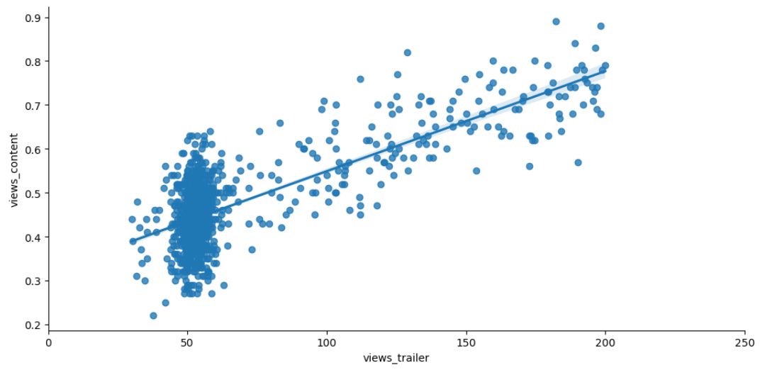
Figure 54: views_trailer vs views_content correlation
with a positive correlation of 0.75 (refer heat map)

